**EXP 10 FONT COLOUR CHANGER**

# 🎯 AIM

To develop an Android application that **changes the font and color of a TextView** and shows a **toast message** when the user clicks a button.

# ALGORITHM

1. Start the app.
2. Show a TextView with default text.
3. Display a Button: Change Style.
4. When the button is clicked:

o Change the font style (bold/italic/custom). o Change the text color (to a vibrant color). o Show a Toast: "Style Changed!" 5. End.

# 💻 CODE

✅ **MainActivity.kt**

kotlin CopyEdit

package com.example.textstyler

import android.graphics.Color import android.graphics.Typeface import android.os.Bundle import android.widget.*

import androidx.appcompat.app.AppCompatActivity

class MainActivity : AppCompatActivity() {

lateinit var myText: TextView lateinit var styleButton: Button

override fun onCreate(savedInstanceState: Bundle?) { super.onCreate(savedInstanceState) setContentView(R.layout.activity_main)

myText = findViewById(R.id.myText)

styleButton = findViewById(R.id.styleButton)

styleButton.setOnClickListener { myText.setTextColor(Color.parseColor("#E91E63")) // Vibrant pink

myText.setTypeface(null, Typeface.BOLD_ITALIC)

myText.textSize = 24F

Toast.makeText(this, "Style Changed!",

Toast.LENGTH_SHORT).show()

}

}

}

🎨 **activity_main.xml**

xml CopyEdit

<?xml version="1.0" encoding="utf-8"?>

<LinearLayout

xmlns:android="http://schemas.android.com/apk/res/android" android:orientation="vertical" android:gravity="center" android:layout_width="match_parent" android:layout_height="match_parent" android:background="#FFF8E1" android:padding="24dp">

<TextView

android:id="@+id/myText" android:layout_width="wrap_content" android:layout_height="wrap_content" android:text="Welcome to My App!" android:textSize="20sp" android:textColor="#333" android:padding="16dp" />

<Button

android:id="@+id/styleButton" android:layout_width="wrap_content" android:layout_height="wrap_content" android:text="Change Style" android:textColor="#fff" android:backgroundTint="#F48FB1" android:layout_marginTop="20dp" android:padding="10dp"/>

</LinearLayout>

**OUTPUT:**

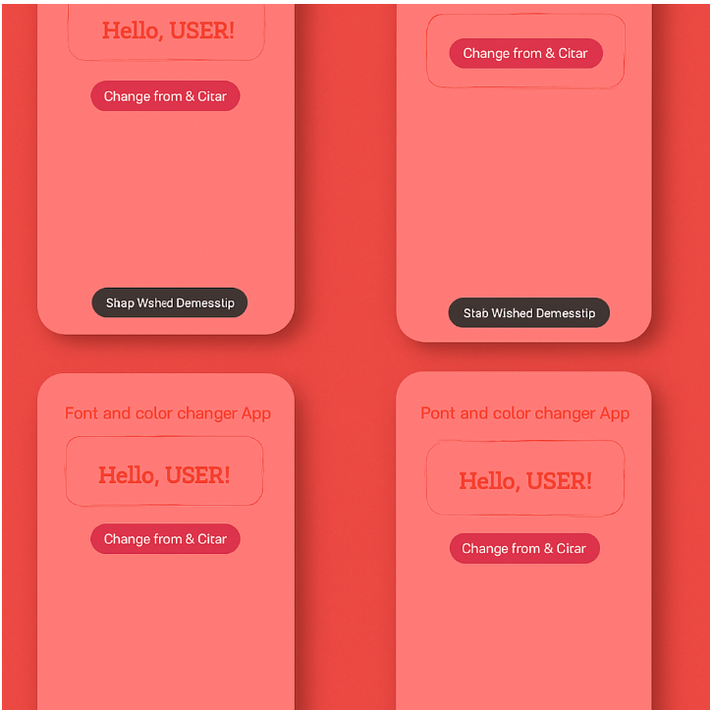

✅ **RESULT**

* When the app runs, a TextView displays the message.
* Pressing the **Change Style** button:

o Changes the **text color to pink**, makes it **bold italic**, and increases the size.